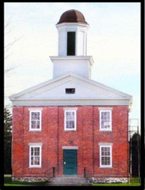
CLARKSON HISTORICAL NEWSLETTER
MAY 2026

Letter from the President

Dear CHS Members and /friends:

You can tell it is spring, one day it’s raining, the next day is sunny but with a possibility of snow in the forecast! Welcome to upstate NY.

We have a few events to look forward to as we wait for spring weather and summer to arrive. Please join us on May 30th from 4-8PM when we will be open for Brockport’s “Night at the Museum.” Hope to see you there.

Thank, you. Anita OBrien CHS President

CHILDREN’S PROGRAMS:
Summer Camp, where children will experience what life and school were like in the “Good Old Golden Rule Days” with cursive writing thrown in for good measure (but without the hickory sticks, thank you)
Our four-day summer camp will be held in the mornings August 17-20.
Camp Volunteers: We are looking for volunteers to help with the camp, as well as lead classes in art, music, history and other topics.
So… If you have a special talent and would like to volunteer your time, or know someone who might be interested, email us at clarksonhistorical@gmail.com.
And, if you would like to share other ideas for the camp, please share them with us.

Thank you
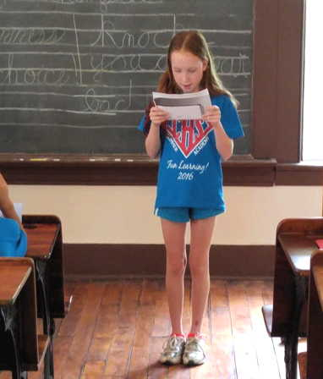
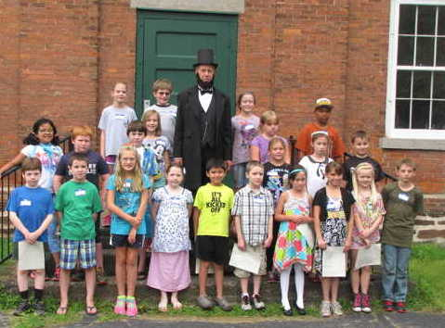
MY WEEKLY READER, SOME HISTORY:

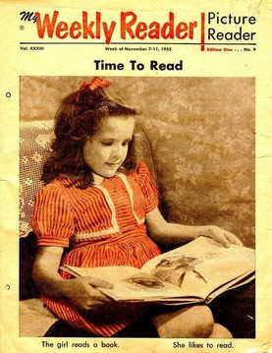
The older readers among us may recall this weekly publication. It was first published in 1928 by American Education Press to make current events available to children.
Founded with the goal of fostering future newspaper readers, it became a classroom staple for decades delivering educational stories, and interactive puzzles to many students.

The idea came from educator Eleanor M. Johnson whose goal was to balance children’s reading to current events. The first issue was issued September 21, 1928 and became a classroom fixture. The end of an era was in 2012 when the publication was acquired by Scholastic Inc. and with declining subscriptions and digital media the Weekly Reader folded. The publication is remembered for its role in developing literacy and civic awareness for generations of children.

Thanks to Leanna Hale, the Academy has a few copies of this great publication.
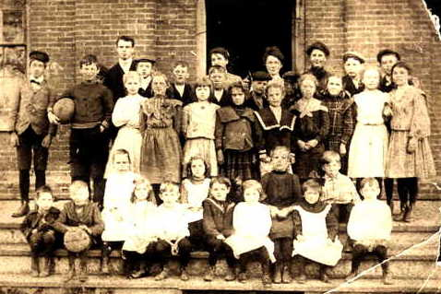
The Clarkson Academy Building was built in 1853 to replace the original structure, which had burned in 1852. It continued as an academy and later served as Clarkson’s two-room public school until 1956.
Note the varied ages of the pupils, and the stylish dandy on the left, in this 1896 photo.

Upcoming events:
Please look information on our Clarkson Historical Society Facebook page.

To our members: We are always looking for help with our many projects, so please consider getting involved—as a board member, or even just helping out with a project or two.
For questions or suggestions, please contact us at: Clarksonhistorical@gmail.com
Lecture series: Please look information on our Fall series on our website.

Thanks to our sponsors:
- Sara’s Garden Center. Spring is finally here, so shop there for your garden needs. And, if you are a CHS member, use your member’s discount card.
- Graham Global Logistics 13 Water Street Suite 1 Brockport NY 14420

