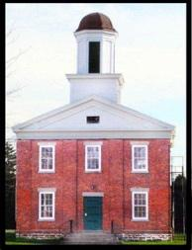
CLARKSON HISTORICAL SOCIETY
NEWSLETTER
JUNE 2026
From the President:

Dear CHS Members and friends:

By the time you get the newsletter it will be summer, thank goodness. It has been a long and wet spring!

June’s “Night at the Museum” was a success, and we were able to meet many new neighbors, friends and visitors who took in our displays. Quite a few also entered our adult cursive contest. Congratulations to Sue Seidle, our Cursive winner. And thanks to our volunteers for this event, Bonnie Howlett, Leanna Hale and Christopher Graham – and to the cursive-aware students who judged our cursive contest.

Anita O’Brien, CHS President

CHILDREN’S PROGRAMS:
Summer Camp: We are preparing for our four-day summer camp, which will be held in the mornings, August 17-20.
We have a great schedule planned and if you know of any child in 4th or 5th grade who would like to join us, please see the entry form on our website (Clarksonhistoricalsociety.org). Registration is open until August 10th.
Seymour Library Homeschool Children’s Reading Program:
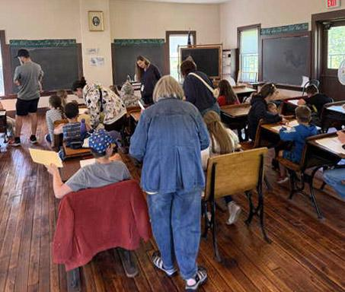
On Thursday May 21st the CHS hosted over two dozen home-schooled children of all ages, along with their parents and grandparents, for a very realistic look at a typical school day in the Clarkson Academy 150 years ago. The event was coordinated by Beth Woodruff from the Seymour Library staff and CHS board members.
The “day” started with the ringing of the recently-refurbished original 1853 school bell, the reciting of the Pledge of Allegiance and a welcome assembly on the Academy’s front steps. We then moved to the second floor, which is permanently set up with dozens of period-correct student desks, chalkboards, textbooks and maps. The backdrop provided a lively look at what subjects were taught, what was expected of each pupil, and a brief lesson on writing their names in cursive. After a brief “recess” and water break we moved to the first floor, where several tables encouraged interaction with antique lunchpails, books, and other teaching materials. The school day ended in a rousing hands-on experience with games popular with schoolchildren “back in the day.” Everyone had a great time; our thanks to all who helped make this day happen!
Note from Clarkson Town Historian Leanna Hale:
Just a reminder from last month. Leanna has met with the Sons of the American Revolution and is currently working to determine the location of all of the Revolutionary War veteran grave sites located within the Town of Clarkson. The Sons of the American Revolution will be present to acknowledge the Revolutionary soldiers at the Clarkson Good Neighbor Days in August.
New mailing address: The US Postal Service has now permanently closed the Clarkson Post Office. Our PO Box 600 has been moved physically to the Brockport PO.
<<< PLEASE NOTE OUR NEW MAILING ADDRESS >>>
CLARKSON HISTORICAL SOCIETY, PO BOX 600
BROCKPORT, NEW YORK 14420
Lecture series:
Please look at information on our Fall series on our website. Clarksonhistoricalsociety.org

Thanks to our sponsors:
Sara’s Garden Center. Planting season here, so shop at Sara’s for your garden needs. And, if you are a CHS member, use your member’s discount card.
Graham Global Logistics 13 Water Street Suite 1 Brockport NY 14420

Upcoming events:
Please look at information on our Clarkson Historical Society Facebook page.

To our members: We are always looking for help with our many projects, so please consider getting involved—as a board member, or even just helping out with a project or two.
For questions or suggestions, please contact
Clarksonhistorical@gmail.com

Clarksonhistoricalsociety.org
Clarksonhistorical@gmail.com

